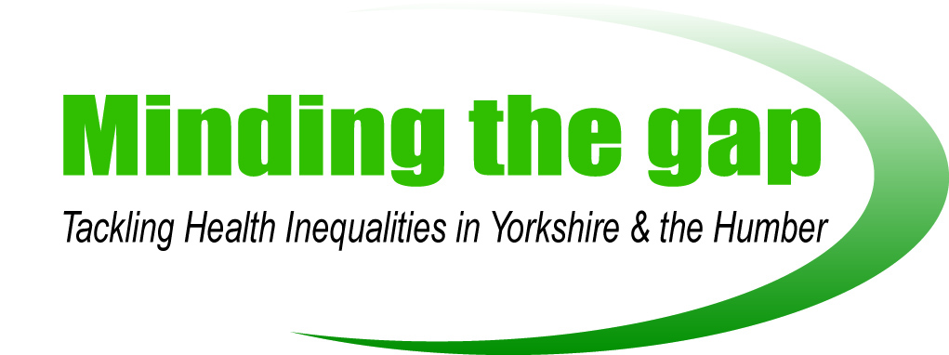
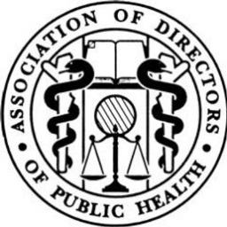

‘A Tale of Two Cities’

Leeds City Hilton, Leeds
4th December 2017
10:20am to 4:20pm

We would be grateful if you could spend a few minutes completing the following questionnaire in order to help us to ensure that future events from the project are of a high standard and are focused on the right topics.

How did you rate the following aspects of this event?

 | Excellent | Good | Fair | Poor
Organisation/Administration | ☐ | ☐ | ☐ | ☐
Venue | ☐ | ☐ | ☐ | ☐
Food / Refreshments | ☐ | ☐ | ☐ | ☐
Speakers | ☐ | ☐ | ☐ | ☐

Did the presentations cover the issues in relation to the focus of the event?

Presentations Completely Mostly Partly Not at all
Prof. Clare Bambra - Newcastle University ☐ ☐ ☐ ☐
Paul Lincoln OBE - UK Health Forum ☐ ☐ ☐ ☐
Dr. Stephen Battersby - EH&H Consultant ☐ ☐ ☐ ☐
Prof. Tim Doran - University of York ☐ ☐ ☐ ☐

Workshops
Juliann Hall - SYHA ☐ ☐ ☐ ☐
Cllr. M. Foy, A. Wiseman and N. Wilkinson - GCC ☐ ☐ ☐ ☐
Sally Jones - Bradford MDC ☐ ☐ ☐ ☐

What aspect of the day did you particularly like?

How could we have improved the event?

For future events are there any topics you would like to see covered?

Any other comments?

Many thanks for completing this form

