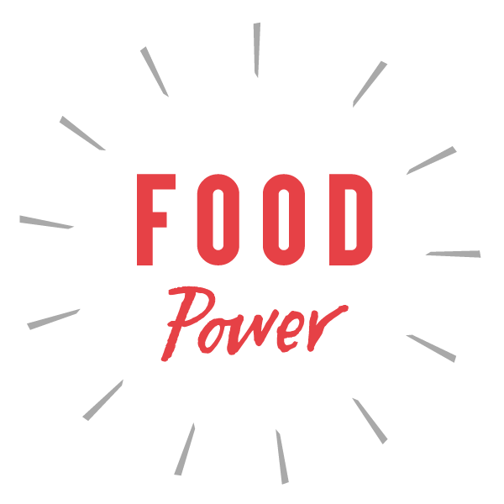 | Building a resilience toolkit in Leeds]  Food Wise Leeds, May 2021

Building local food resilience in Leeds

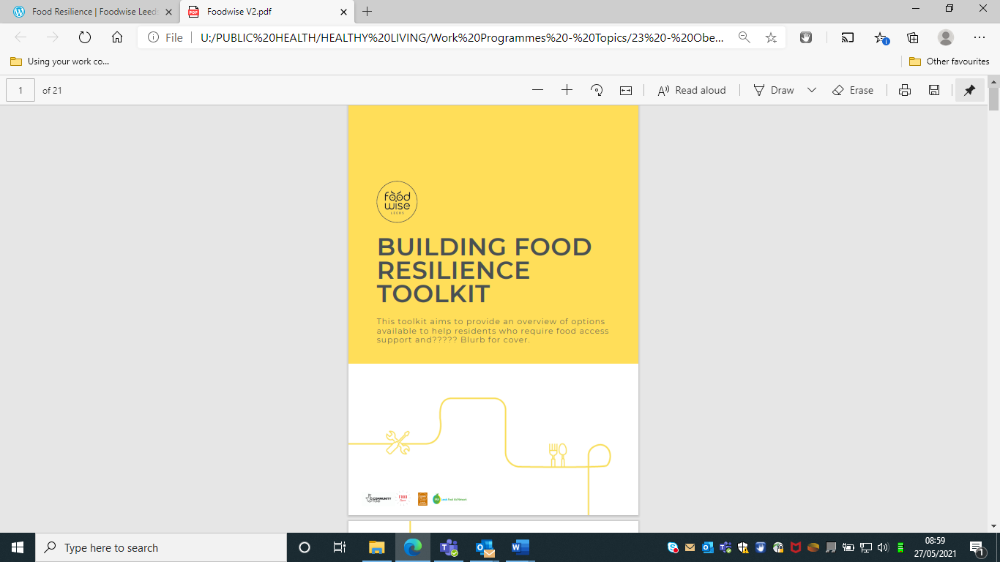
The Building Food Resilience Toolkit aims to support food aid providers to use information and understand ways to help support people back to food independence.

Learning from the current food aid provision in the city system has highlighted:

A need to implement a “Making Every Contact Counts” approach across food aid providers to give staff and volunteers the confidence and skills to explore the circumstances that have resulted in the need for food aid support

A need for clearer information on signposting opportunities in the city (based on the challenges identified directly by food aid providers).

A need to share learning amongst food aid provider to encourage different models of food aid provision moving from free food parcels to other provision such as “pay as you feel”, food pantry, cook and take, social supermarket, mini markets which offer greater choice, ownership and dignity.
To help shape the content of the toolkit, Food Wise Leeds organised two webinars to introduce the concept of building food resilience and capture views and to showcase good practice from a range of different food aid providers who have transitioned from crisis support to approaches that greater enable food independence. The webinars can be viewed here: https://foodwiseleeds.org/food-resilience/

“I’m proud of the massive work being done in Leeds and other cities to tackle food poverty... Together we will be able to change things for the better. “

Neruka White, Neuka’s Soup Kitchen

Challenges and learning
Throughout the project we have learnt more and more about the valuable, skills, knowledge and experience of food aid providers in the city and we have agreed to continue to find ways to help good practice sharing. The biggest challenge we have experienced had been to capture the learning and toolkit content with timescale, we could go on for another 6 months capturing information, but we have agreed to continue working through our networks to keep the toolkit up to date – there has been an overwhelming interest in the toolkit.

Next steps

Outcomes
  - Worked as a cross sector steering group to develop the toolkit including food aid providers
  - Hosted 2 webinars with food aid providers attended by 58 projects
  - Captured feedback on the toolkit drafts from 15 stakeholders working across the food provision system.
The Building Food Resilience Toolkit is part of the cities response to support people back to independence. The toolkit will be introduced to providers in a number of ways, including a final webinar. We are discussing the development of a training programme for food aid providers to reinforce messages from the toolkit.
The learning from the webinars is going to be written up and presented to the Council to encourage the development of a Building Food Resilience vision for the city to move forward from the cities work as part of the Emergency Response to Food during COVID 19.

