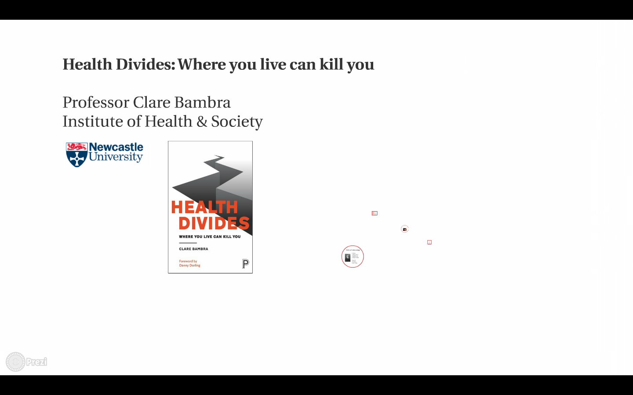

[Link](https://prezi.com/w0whnbfplr4f/health-divides-leeds/?utm_campaign=share&utm_medium=copy)