**Doncaster Family Food programme – Overview**

Doncaster Council are adopting a compassionate approach to health and wellbeing. This means we acknowledge a person’s health is not just about their individual lifestyle choices and behaviours. There are many wider environmental, commercial, social, and economic determinants of health that impact a person’s quality of life and health outcomes that are outside of that individual’s control. We believe primarily that public health interventions should focus on changing systems, rather than individual behaviours.

Where we do focus on individuals, we will give compassionate and empowering support aimed at helping them to navigate the unfair environments they live in. We want to ensure our programmes are driven primarily by kindness and compassion; do not perpetuate stigma; and fully acknowledge the mental and financial burden poverty, and inequality places on people.

One of our key focuses is how we support our citizens, and in particular, children and young people, to enjoy varied and nutritious diets. Good family nutrition is a vital part of a child’s growth and development. Embedding good feeding habits from as early as possible gives the best chance of a child reaping the benefits of a varied, nutritious diet, alongside forging a positive and peaceful relationship with food.

Factors influencing diet are complex and multi-faceted. Poor diet and associated health conditions are strongly associated with wider, social determinants of health and yet most interventions focus on individual responsibility to change behaviour.

Interventions that focus on information, advice and skills often fall short by failing to adequately address the impact that circumstance and environment have on a families’ ability eat a varied and nutritious diet, such as psychological stress (worries such as paying the bills), having free time to plan/support mealtimes, food affordability and accessibility. They also fail to address how the parents own experience, values, and beliefs surrounding food impacts on the way they feed their children.

We are excited to announce the development of a new service - Doncaster Family Food (FF) Programme - that will to support parents/carers to feed their child/children in a way that supports a lifelong trajectory for good health and wellbeing.

The FF Programme will consist of 1:1 or group support for families during pregnancy or soon after birth, to optimally feed their children through a combination of knowledge building; practical skills and tools; and therapeutic interventions to explore parents own relationship with food/body and how this impacts on parenting/feeding style.

**Aims & objectives**

The programme aims to support parents/carers to feed their child/children in a way that supports a lifelong trajectory for good health and wellbeing.

Programme objectives are:

* Supporting parents/carers to address their own ‘journey’ with food/weight issues/internalised weight stigma – how this impacts on the wider family and feeding practices
* Parents/carers have a good understanding and tools to support providing their child with a varied and nutritious diet, starting from birth, though weaning, and as their child grows
* Families are given practical advice and tools, specific to their circumstances, to support them to navigate the challenges to feeding their family as they would ideally like to

The programme intends to provide parents/carers with the tools to support their children to;

* Grow up with positive and peaceful relationships with food
* Retain their natural intuition for hunger/fullness cues
* Not assign moral value to any particular type of food
* Recognise their own food preferences and experiences eating different types and amounts of food
* Enjoy a wide variety of foods understanding that different foods can have both physical and mental effects

**Service elements**

Within The Family Food Programme Team the following skillsets will be required:

• Nutrition or dietetics

• Food safety

• Motivational interviewing / behaviour change techniques

• Promoting health gains

• Health promotion

• Cognitive Behavioural Therapy (CBT), alternative or similar approaches

• Understanding and awareness of intuitive eating

• Child development

• Attachment

• Feeding styles e.g. ‘Division of Responsibility’

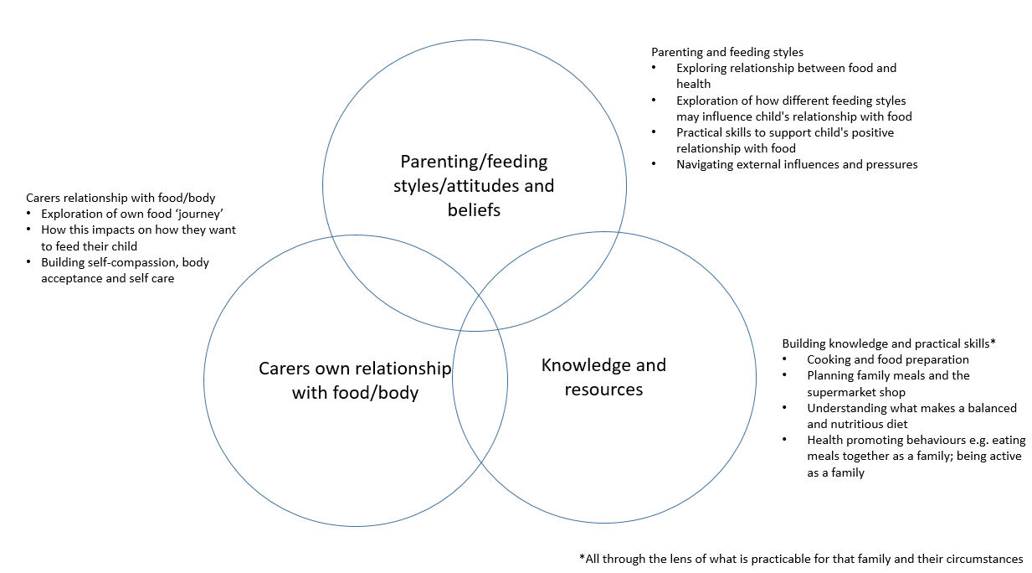

**Who is the service for?**

The programme will engage as early into a pregnancy as possible. The programme is to be targeted during pregnancy or soon after birth, and includes families accessing support to conceive including IVF. The booking-in appointment with the midwife is a key opportunity for engagement. The programme is for first-time parents, as well as those who have other children.

The programme will be available for the pregnant or postnatal parent and other significant adults /carer s in the family. The programed is aimed at supporting adults in the family unit, and children will only be introduced to participate if deemed beneficial for family (e.g. child involved in food preparation session).

**What the service is not**

Family Food Programme is not a weight management service, for adults or children in the family. At no point, during the programme will weighing of adults or children be offered or carried out. The approach will adopt principles of a weight neutral practice which strives to focus on health gains; build self-worth and self-esteem in participants; and maintains a holistic focus given that our health and wellbeing is multidimensional.

**How do we want to measure success?**

We want the successes of this programme to be defined primarily by the families receiving the intervention. Not all outcomes will be appropriate for each family, and families will be able to choose their own outcomes based on the areas that are important to them. Using strengths based approach, families can identify assets that will enable them to achieve the changes they want to make. We believe this family-led, strengths based approach is more likely to lead to long term, sustainable changes that will build self-efficacy. Success measures may include, but not be limited to: improved family nutrition; improved mental health; improved home life/family dynamic.