
News Brief – No. 118 | 9 October 2018

Dear Councillor Philip Barrett

Welcome to the One Hundred and Eighteenth edition of the ADPH Minding the Gap News Brief, the Yorkshire and Humber Health inequalities Programme.

World Leaders Place Lifestyle Choices and Health Back on the Individual
World leaders have side-stepped taking action against industries that fuel “lifestyle” diseases ahead of Thursday’s United Nations High Level Meeting on Non-Communicable Diseases (NCDS). The inclusion of language on ‘empowering individuals to make healthy choices’ fails to recognise that people cannot make healthy choices if the environments in which they live do not provide such choices.

Article

Reducing Health Inequalities through New Models of Care
This report assesses the potential and opportunities for new care models to drive a health system that focusses on population health, reduces health inequalities and takes action on the wider determinants of health. If new models of care can capitalise on the opportunities in the new system and deliver these approaches, then overall improvements to health, reductions in health inequalities and reductions in demand for health care services should result. However, currently there is only partial uptake of the available opportunities through existing mechanisms. As such there is scope to further develop action on health inequalities which this report intends to support.

While many of the levers to improve health currently lie outside the remit of healthcare services, there are significant opportunities for healthcare organisations to do far more to improve population health and reduce inequalities in health, and NHSE have acknowledged this. New Care Models, for example, are well placed to build elements of a health system approach through integral mechanisms and approaches.

Paper

The Social Determinants of Health and the Role of Local Government
Health inequalities between the least well-off and the better-off continue to grow in the UK, after a great deal of attention has been focused on it and despite the government’s rhetoric. Part of the mismatch between the policy goal and the reality in practice is a failure, for numerous reasons, to get a proper grip on the social determinants of health. Tackling health inequalities through the NHS and secondary prevention, though important and necessary has not been sufficient to narrow the health gap.

This is quite an old article, but the content remains appropriate and it still accurately describes the situation as it is today. The document provides a consideration, through the views of different writers, of the role of local government in addressing health inequalities through action on the social determinants of health and the diagram below is self-explanatory.

Papers

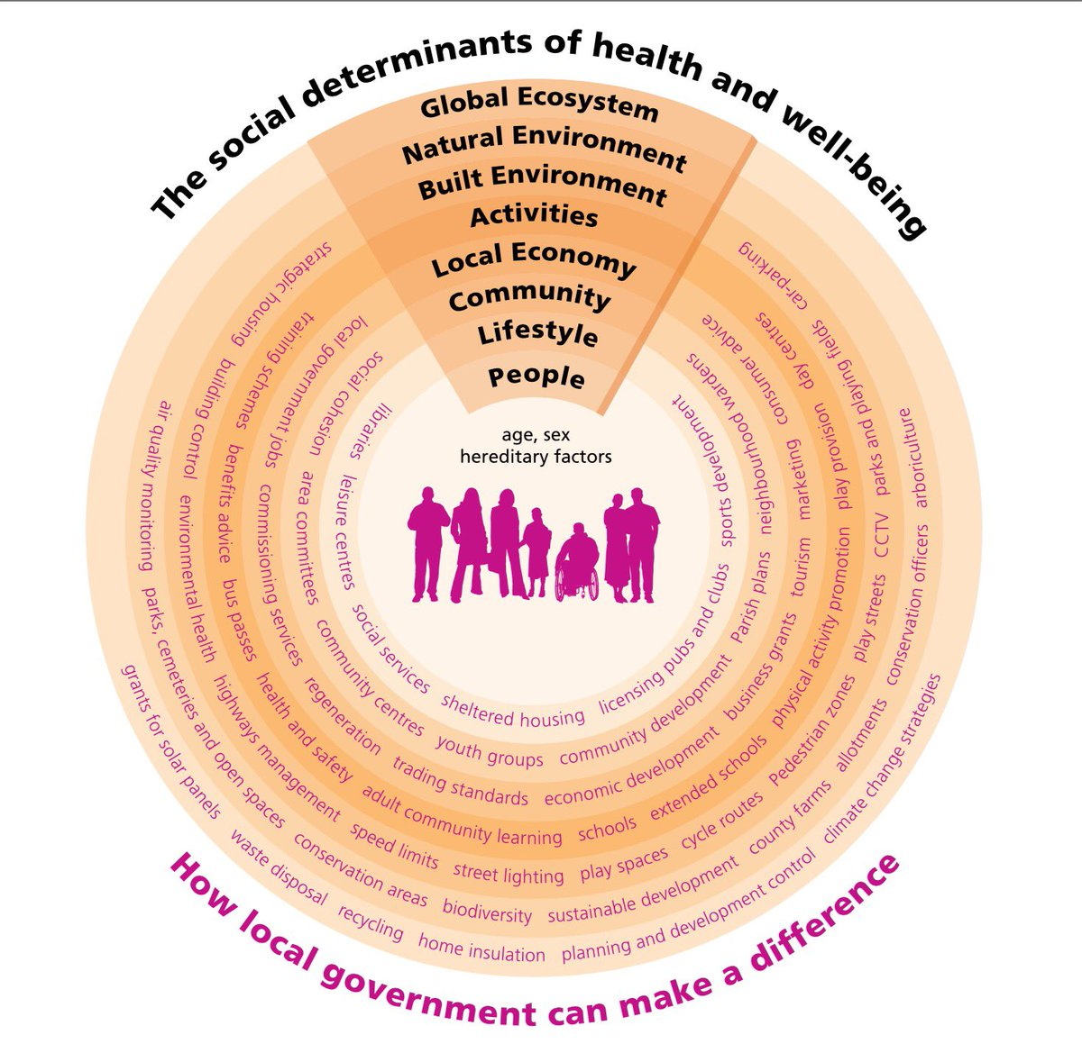

A New Measure of Poverty for the UK
This report outlines a new approach to poverty measurement for the UK and provides original analysis that demonstrates the fundamental changes to our understanding of poverty it creates. Most importantly, the approach, results and recommendations in this report are supported by every Commissioner. They truly represent a consensus view of how we should measure and understand the incidence of poverty in the UK and the experiences of those who are in poverty.

The report highlights that 7.7 million people are living in persistent poverty. These people have spent all or most of the last four years (and more) in poverty. Persistence rates are particularly high for children and working-age adults who live in workless families and families with a disabled person. Given that we know that long periods in poverty can be particularly damaging to people’s lives and prospects, this is a significant concern.

The report also highlights a range of groups that have previously been under-represented in official measures of poverty. For example, nearly half of people in poverty live in families with a disabled person. Compared to previous measures, it also shows that those families struggling to make ends meet because of childcare and housing costs and those who lack a financial buffer to fall back on are much more likely to be in poverty.

Report

Social Media, Young People and Mental Health
Evidence about the roles social media play in relation to our mental health is still emerging. As with any new technology of such significance in people’s lives, there has been a great deal of public and political concern about the effects of social media use on young people’s physical and mental health and safety.

This briefing paper is based on a brief scan of evidence from a range of sources to identify key themes in what is known about the impact social media (and their use) can have on young people’s wellbeing, and the ways in which they can be harnessed positively. It is not a comprehensive review of the literature but is intended as a stimulus for debate and discussion.

Briefing paper

The Toxic School Run: UK Children at Daily Risk from Air Pollution
Every day, millions of children in our towns and cities are exposed to dangerous levels of pollution in the areas where they live, learn and play. This invisible danger could be stunting their lung growth, increasing their risk of asthma and potentially damaging their brain growth.

This research looks at children’s exposure to air pollution across the school day. The data finds that children are disproportionately exposed to higher doses of pollution during the school run and while they are at school – particularly at break times when they’re in the school playground. The report suggests that major gains for children’s health could be made if funding, interventions and policies were targeted at pollution reduction around schools and nurseries, and on the school run itself.

Report

All the Lonely People: Loneliness in Later Life
Many people experience loneliness at some point in their lives. For the majority the feeling of loneliness passes, yet for some it can persist, undermining their well-being and impacting negatively on their quality of life.

This report presents new evidence about what Age UK knows about loneliness among people aged 50 and over, what increases the chances of people experiencing loneliness and how best to help those older people who are persistently lonely. The focus throughout is on the need for approaches to reducing loneliness to be tailored to the circumstances of the individual.

Report

What Price Safe Motherhood? Charging for NHS Maternity Care in England and its Impact on Migrant Women
This report explores the impact on migrant women who faced charges for NHS maternity care during and after their pregnancies. It was carried out in response to growing concerns that women at risk of being charged for maternity care are delaying or avoiding care. It is based on in-depth interviews with sixteen women from eleven countries in north and sub-Saharan Africa, Latin America, south-east Asia and the Caribbean who were charged, or expected to be charged for their NHS maternity care. It also draws upon case summaries from Maternity Action’s Maternity Care Access Advice Service.

Most of the participants were socially and economically vulnerable but faced debts for bills from the NHS. The research found that NHS charging gives rise to stress and anxiety among migrant women who are pregnant and new mothers. Some women were deterred from attending maternity care and so did not receive needed clinical care and social support, with possible long-term consequences for their own and their children’s health.

Report

How Should Academics Engage in Policymaking to Achieve Impact?
Academics are under increasing pressure to engage with policymakers, practitioners, publics, and traditional and social media. However, they face major ethical, personal, and practical dilemmas about if, when, and how to engage to influence policy. The positive and negative effects of such engagement, from workplace promotion to personal intimidation and social media abuse, are not experienced equally and this should be a constant throughout.

This article reviews the advice from the academic and 'grey' literatures to identify a list of dos and don'ts for academics seeking ‘impact’ from their research. From ‘how to do it’ sources, we identify consistent advice on how to engage effectively, largely because it is necessarily vague, safe, and focused primarily on individuals. We then consider the wider policymaking system in which actors make political choices and have unequal access to impact opportunities. We identify the effort it takes to have actual policy impact and how far academics should be expected to go to secure and take credit for it.

Paper

Health Profile for England: 2018
As a society, people are living longer but often in poorer health and stubborn inequalities persist. Good health is about much more than good healthcare – a high-quality education, a warm home, and a good job are just as important to a healthy standard of living.

This report summarises the health of people in England in 2018 and provides an update to the first Health Profile for England. The report includes forecast data for several key indicators, for the 5 years up to 2023 and a separate chapter on the health of children in the early years.

Report

Inequalities In Mental Health And Well-Being In A Time Of Austerity: Follow-Up Findings From The Cohort Study
In response to the 2007/8 financial crisis and the subsequent ‘Great Recession’, the UK government pursued a policy of austerity, characterised by public spending cuts and reductions in working-age welfare benefits. This paper reports on a case study of the effects of this policy on local inequalities in mental health and wellbeing in one local authority, an area with very high spatial and socioeconomic inequalities.

Follow-up findings from a prospective cohort study of the gap in mental health and wellbeing between the most and least deprived neighbourhoods s is presented. The main findings are that the significant gap in mental health between the two areas remained constant over the 18-month study period, whilst there were no changes in the underlying determinants. These results may reflect that the cohort sample was older than the general population and pensioners in the UK have largely been protected from austerity. The study therefore potentially provides further empirical evidence to support assertions that social safety nets matter – particularly in times of economic upheaval.

Report

Mental Wellbeing, Reading and Writing: How Children and Young People’s Mental Wellbeing is Related to Their Reading and Writing Experiences
People who struggle with literacy are also more likely to have poor physical health. There is evidence to suggest that higher levels of mental wellbeing and life satisfaction can positively impact on academic achievement and there is a link to the ability to cope with stress, which can affect pupils’ ability to learn. Some research suggests that five-year-olds with poor vocabulary skills are one and a half times more likely to have mental health problems as adults. Emotional wellbeing has also been linked to non-cognitive skills, such as resilience, grit, self-esteem, confidence and motivation, which in turn may have a positive impact on pupil achievement.

This report explores the link between mental wellbeing, reading and writing enjoyment, attitudes and behaviours. The report also highlights a link with age, indicating that “children’s well-being falls as they get older, with particularly sharp falls in well-being for both boys and girls between the ages of 13 and 14 and 16 and 17”. Other studies have also explored how children in the UK fare compared with their peers in other countries, with children in the UK generally performing slightly below average in terms of their mental wellbeing compared with children in other developed countries.

Report

National Life Tables, UK: 2015 to 2017
Life expectancy at birth in the UK did not improve between 2015 and 2017 and within the UK life expectancy at birth declined by 0.1 years for males and females in Scotland and Wales. Life expectancy at age 65 years in the UK did not improve and remained at 18.6 years for males and 20.9 years for females. Around one in five new-born males and one in three new-born females in the UK could expect to live to at least age 90 years; the chance of survival to age 90 years has remained virtually unchanged since 2012, whilst life expectancy in the UK remained lower than in many other comparable countries internationally.

Report

Putting Health into Place: Introducing NHS England’s Healthy New Towns Programme
Places where people live have a significant impact on their mental and physical health but that impact is too often negative. Many high streets are dominated by fast-food takeaways. Driving is often the only – and most convenient – way to get around. Poorly maintained parks and green spaces do little to invite walking or play. In numerous ways, neighbourhoods, towns and cities restrict people’s choices and chances to lead healthier, more active lives.

The Healthy New Towns is a three year programme, quested with looking at how health and wellbeing can be planned and designed into new places. It brings together partners in housebuilding, local government, healthcare and local communities to demonstrate how to create places that offer people improved choices and chances for a healthier life. However, the jury is still out as to level and quality of community involvement and self-determination is taking place.

Report

Health Inequalities: The NHS Plan Needs to take More Responsibility
It's good news that the NHS long-term plan has a work stream—or, part of a work stream—on health inequalities. Dave Buck outlines the key elements he wants to see included and why tackling inequalities should already be core business for the NHS.

Blog

Open Letter From UK Public Health Scientists to Public Health England Regarding Partnerships with the Alcohol Industry
This letter sent to Duncan Selby on behalf of public health scientists, journal editors and directors of UK public health research initiatives, express’s the signatories concerns about partnerships between Public Health England and the alcohol industry. The authors believe that the related collaboration between Public Health England and the alcohol industry puts at risk the general public’s confidence in PHE’s and its commitment to the highest scientific standards and the promotion of policy advice informed by the best available evidence.

They suggest that the reputational risk to PHE’s status as a provider of impartial, evidence-based advice is significant. Researchers have previously raised concerns regarding Drinkaware and other organisations linked to the alcohol industry providing inaccurate, partial or ambiguous information within health promotion campaigns. It is for these and other reasons that PHE’s own evidence review concluded that, “the delivery of education messages by the alcohol industry has no significant public health effects”. In its 2014 statement of priorities, PHE is committed to ensuring that, “credible, evidence-based advice is available on the key issues relating to the public’s health”

Letter

Author Talks
Professors Richard Wilkinson and Kate Pickett are available to give talks about The Inner Level and inequality to interested audiences in the UK and across the world. They are particularly keen to spread the word to as many people as possible and so will prioritise larger audiences, ideally of 100 people or more.

They do not charge speaker fees but do ask that standard class travel costs (and accommodation costs if needed) are covered. They also invite donations to be made to The Equality Trust which we will be happy to discuss with you. Richard and Kate are based in York and the time and distance involved in travel to an event are factors to be considered when making the donation.

Ideally, they would prefer to do events during the working week but weekend bookings are possible and, again, are a factor to be considered when making the donation.

If you wish to book a talk, please email and we will get in touch with you as soon as possible to make arrangements. Thank you for your support in the fight against inequality. It is not inevitable. We can build a better world where all can flourish.

The Inner Level: How More Equal Societies Reduce Stress, Restore Sanity and Improve Everyone’s Wellbeing
(Richard Wilkinson, Kate Pickett)
Why is the incidence of mental illness in the UK twice that in Germany? Why are Americans three times more likely than the Dutch to develop gambling problems? Why is child well-being so much worse in New Zealand than Japan? As this ground-breaking study demonstrates the answer to all these hinges on inequality.

In ‘The Spirit Level’ Richard Wilkinson and Kate Pickett put inequality at the centre of public debate by showing conclusively that less-equal societies fare worse than more equal ones across everything from education to life expectancy. The Inner Level now explains how inequality affects us individually, how it alters how we think, feel and behave. It sets out the overwhelming evidence that material inequalities have powerful psychological effects: when the gap between rich and poor increases, so does the tendency to define and value ourselves and others in terms of superiority and inferiority. A deep well of data and analysis is drawn upon to empirically show, for example, that low social status is associated with elevated levels of stress, and how rates of anxiety and depression are intimately related to the inequality which makes that status paramount.

Wilkinson and Pickett describe how these responses to hierarchies evolved, and why the impacts of inequality on us are so severe. In doing so, they challenge the conception that humans are innately competitive and self-interested. They undermine, too, the idea that inequality is the product of 'natural' differences in individual ability. This book sheds new light on many of the most urgent problems facing societies today, but it is not just an index of our ills. It demonstrates that societies based on fundamental equalities, sharing and reciprocity generate much higher levels of well-being, and lays out the path towards them.

Read more here

Events

SAVE THE DATE
Community, Culture and Health - ‘A Christmas Carol’

Venue: Doubletree by Hilton, 24 Ferensway, Hull, HU2 8NH
Date: 11th December 2018
Times: 9:30am to 4:00pm

Minding the Gap is delighted to present the seventh of a series of events which re-visits the policy objectives highlighted in The Marmot Review – Fair Society, Healthy Lives. This conference will focus on the interconnections between Community, Culture and Health Inequalities.

This conference will explore the current theory, evidence and practice to better health and wellbeing and ask the question ‘what keeps us healthy?’ rather than ‘what makes us ill?’ The voice of community-focused organisations and partnerships and the relationship with policy and practice has never been as important. We also need to recognise the powerful contribution the arts and culture can make to health and wellbeing and we will be hearing from some of the main protagonists behind Hull, City of Culture 2017.

Health inequalities cannot be solved exclusively by public health alone. Collaboration between health professionals and those working in others – e.g. urban planners, environmental officers, architects, employers, housing authorities, educators, social workers and the community and voluntary sector - is essential.

The challenge is to release people’s capacity to engage by addressing the issues that lead to reluctance, disillusionment and disconnection. The conference will look at how policy makers and advisors can learn from the ‘past’ engage with the ‘present’ and build for the ‘future’.

Keynote Speaker::

Professor Jennie Popay, Professor of Sociology and Public Health, Institute for Health Research, Lancaster University
Further details to follow.

Flyer and Booking Form

Yorkshire and the Humber Association of Directors of Public Health
Sector Led Improvement Annual Conference

Venue: Sheffield Hallam University, Charles Street, Sheffield
Date: Friday, 29th March 2019
Time: 10.00am – 4.00pm

The 2019 sector led improvement conference will take place in Sheffield next March. We are currently putting together the programme, which will include a mix of plenary presentations and examples of innovative practice from across Yorkshire and Humber showcased in oral and poster presentations.

The call for abstracts will be issued shortly and booking will open in November 2018. In the meantime, please keep the date clear in your diary.

*Please note that booking for this conference will open in November and each local authority has a set number of places available. Booking will be coordinated by each local authority’s Director of Public Health.

Unsustainable Pressure? The Future of Health & Social Care

Venue: Hayes Conference Centre, Derbyshire
Date: 11th & 12th October 2018

The conference includes Key Note Speakers:

Glen Garrod, ADASS President
Aileen Murphie, National Audit Office
Lyn Romeo, Chief Social Worker for Adults

Learn from practice. The Conference shares over 20 operational and strategic workshop sessions.
This not just another “conference”. It is the best training at the best price. Learn from colleagues who are doing the job and from cutting edge experts. Probably the best event of its kind and now in its 26th year, this is your conference and is organised and run by Commissioners for Commissioners and all those that have an interest in Health & Adult Social Care.

Price: only £175 plus VAT Early Bird (public sector)
According to the organisers the price includes, Fantastic presentations, overnight en-suite accommodation and all meals, a money back guarantee, the opportunity to network with commissioners and free taxi from Derby station (if travelling by train) and return after the event.

Bookings can be made Here

For a paper booking form contact martin@ncctc.co.uk or for further questions or queries call 07598450728 or 01926741811

All data is secure on the Wakefield Metropolitan District Council server, any access to the data is password protected. Under no circumstances will MtG share copies of mailing lists outside the management team.

For full details of the Minding the Gap data protection Transparency Notice statement please click here

If you’d like to remove yourself from the newsletter distribution list all you have to do is reply to this message with UNSUBSCRIBE as the subject of your message and we'll remove all reference to you from our records.

If you know of colleagues or other people that would be interested in being added to the distribution list for this News Brief, please feel free to forward a message containing their e-mail address.

If you have any queries around submitting an article for the Minding the Gap News brief please contact
Ian Copley
Project Co-ordinator
Minding the Gap
PO Box 700
Burton Street
Wakefield
WF1 3EB

Tel: 01924 305632

E-mail: icopley@wakefield.gov.uk



