Biographies

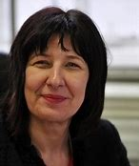
Julia Weldon

Julia Weldon has been Corporate Director of Public Health (DPH) and Adult Social Care at Hull City Council since November 2013, and is the authority’s lead advisor and champion on all health matters.

Julia is a statutory member of the Health and Wellbeing Board, and a member of the CCG Primary Care Commissioning Board. Prior to joining Hull City Council, Julia held a number of Chief Officer roles including Director of Public Health at Redcar and Cleveland, with responsibility for the Tees Valley Shared Service, Teaching Public Health Director for Yorkshire and Humber and Training Programme Director for the Yorkshire and Humber Deanery.

Julia began her career in nursing as a junior sister at Pinderfields Hospital Trust. Her career includes work as Nursing and Health improvement Health Action Zone Manager, and Head of Public Health in Wakefield PCT with a focus on Development, Intelligence and capacity building.

Julia was a member of the Independent Enquiry looking at Health Equality North (Due North) which was commissioned by Public Health England. Julia represents the Yorkshire and Humber ADSPH at National level, is Educational Supervisor for Yorkshire and Humber, the DPH Mental Health Champion and lead for the intelligence community and Interest Group.

Jo Franklin
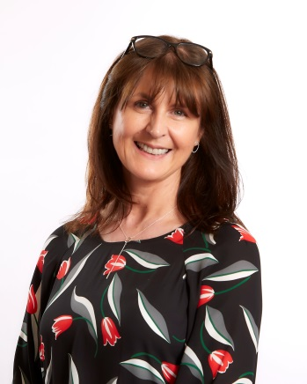
Jo is currently the Business Director at Absolutely Cultured which is the legacy company of the company set up to deliver the UK City of Culture year, Hull 2017. She was instrumental in setting up the company and establishing the governance and corporate systems along with the recruitment of staff and trustees. She started her career at BAE SYSTEMS before moving to the NHS and worked in a range of public health roles at NHS Hull and Hull City Council commissioning and delivering a range of public health programmes including accident prevention, tobacco control, NHS Health Checks and digital health initiatives

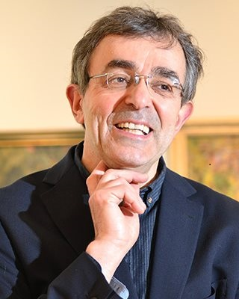
Professor Franco Bianchini

Franco Bianchini is Professor of Cultural Policy and Planning - and Director of the Culture, Place and Policy Institute - at the University of Hull, UK. He is part of a team in charge of the evaluation of the impacts and processes of Hull UK City of Culture 2017.

From 2007-2016 he was Professor of Cultural Policy and Planning at Leeds Beckett University, UK. In 2003 he acted as adviser to Liverpool Culture Company on the preparation of their successful bid for the 2008 European Capital of Culture. He initiated, and was a member of the artistic team for, ‘Cities on the Edge’, a project of cultural co-operation between Liverpool, Bremen, Gdansk, Istanbul, Marseilles and Naples (2004-2009). The project formed part of the programme of Liverpool European Capital of Culture 2008.

From 2010-2014 he was a member of the team preparing the successful bid by the city of Matera, in Southern Italy, for the title of European Capital of Culture for 2019.

His books include Focus on Festivals (co-edited with C. Newbold, C. Maughan and J. Jordan, Goodfellow, 2015), Urban Mindscapes of Europe (co-edited by G. Weiss-Sussex with F. Bianchini, Rodopi, 2006), Planning for the Intercultural City (with J. Bloomfield, Comedia, 2004), Culture and Neighbourhoods: A Comparative Report (with L. Ghilardi Santacatterina, Council of Europe, 1997), The Creative City (with Charles Landry, Demos, 1995) and Cultural Policy and Urban Regeneration: the West European Experience (co-editor, with Michael Parkinson, Manchester University Press, 1993).

His research interests range from the role of culture in urban regeneration (with a particular focus on port cities and on European Cities/Capitals of Culture), to cultural diversity and interculturalism as resources for innovation in urban policy, and the development of urban cultural strategies in the context of the current political, economic and environmental crises.

Dr Nigel D Morpeth

Dr Nigel D Morpeth has worked at four universities in the UK and also worked in community based leisure and events organisation in three local authorities.

He is currently a Research Fellow in the Culture, Place and Policy Institute at the University of Hull. His research, publications and teaching are informed by diverse inter-disciplinary academic groups of Cultural Studies, the Creative Industries, Tourism, Sport and Leisure. During Hull UK City of Culture in 2017, he worked with the Monitoring and Evaluation Team of Hull 2017 Ltd, interviewing artists, curators and peer assessors as part of the visual arts programme. He also worked as a volunteer for Hull 2017 Ltd. and continues in this role for Absolutely Cultured..

Dr Andy Knox

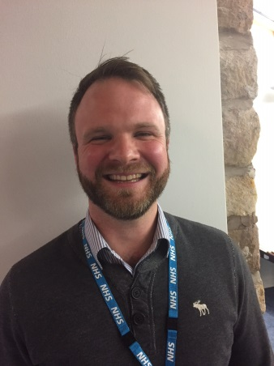
Dr Andy Knox trained as a doctor in Manchester, UK, graduating in 2004. He worked in various hospitals across the city before training as a GP. He was a partner at Lockside Medical Centre in Staybridge, to the east of Manchester before moving to North Lancashire, where he became a partner at Ash Trees Surgery, Carnforth. He is an Executive GP for Morecambe Bay CCG and works with the Better Care Together Team for Morecambe Bay. His particular area of interest is ‘Health and Wellbeing’. He is also training with the NHS Leadership Academy.

Anna Hartley
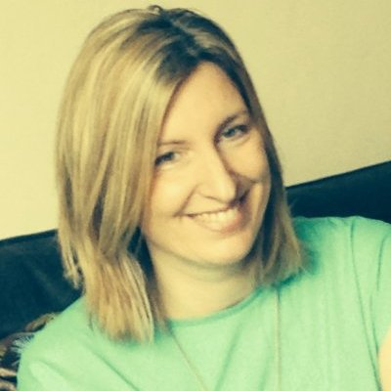
Anna Hartley is currently the Director of Public Health in Wakefield, having qualified as a Public Health Consultant in 2013. She has a specific interest in health and social care integration and evaluation. As well as her public health duties, she has also taken a lead role for adult social care commissioning since November 2016.
Previously Anna has worked at the West Yorkshire Police, Department of Health, NHS Leeds and in the voluntary sector.

Anna is really interested in what ‘gives people a good life’ and what role the statutory sector can play in making that happen. She is motivated by looking at how organisations can work differently in order to deliver better outcomes for the people they serve.

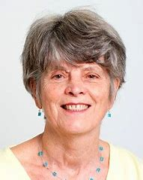
Professor Jenny Popay

Jennie Popay is Professor of Sociology and Public Health at Lancaster University in the UK, Deputy Director of the NIHR School for Public Health Research (SPHR) in England and Director of Engagement for the NIHR Collaboration for Leadership in Applied Health Research and Care for the NW Coast (NIHR CLAHRC NWC). She is co-director of the Liverpool and Lancaster Collaboration for Public Health Research (LiLaC). Jennie has worked as a teacher, policy makers and researcher in academia and in the public and voluntary sectors in the UK, Africa and New Zealand. Her research interests include the social determinants of health and health equity; the evaluation of complex ‘natural’ policy experiments’; community empowerment; and the sociology of knowledge. She has been involved in a wide range of mixed methods studies but has particular expertise in qualitative methods including methods for qualitative and mixed evidence synthesis. Her current research includes an evaluation of a large-scale community empowerment initiative in England and leadership of a programme of work developing and evaluating the impact of action aimed to enhance neighbourhood resilience on health inequalities. She has recently completed an evaluation of the impact on health inequalities and their social determinants of the English New Deal for Communities regeneration programmes and their approaches to community engagement. She also led a collaboration funded by the Medical Research Council in the UK producing online guidance on how to assess the impact of public involvement in research (piiaf.org.uk). She ran the global Social Exclusion Knowledge Network supporting the WHO Commission on the Social Determinant of Health and has held public appointments with the Commission on Health Improvement, the Commission on Patient and Public Involvement in Health, the Bevan Commission in Wales and was the inaugural chair of the English charity, The People’s health Trust.

Workshops

Georgina Swift

Georgina is a Health Improvement Specialist in the Wakefield Council Health Improvement Team. Her current role involves working to embed public health principles throughout the Council and its partners. Part of this work has been supporting Culture to develop the Culture Cures scheme.

Prior to this she worked for 6 years as a Community Development & Health Practitioner supporting to build community capacity and resilience in areas of multiple deprivation in the Wakefield District.

Professor Owen Evans

Owen Evans is Professor of Film in the Media Department and correspondent for arts, health and wellbeing in the Institute for Public Policy and Professional Practice at Edge Hill University. He has published on GDR literature, German film and European Cinema. His monographs have looked at GDR author Günter de Bruyn, and German literary autobiography as a therapeutic form. His articles and chapters comprise studies of The Lives of Others, Sophie Scholl: The Last Days, Kontroll, the work of Humphrey Jennings, the cinema of intercultural dialogue in the films of Fatih Akin, and European Film Festivals. He is co-founding editor of the international journals Studies in European Cinema (Taylor & Francis) and the Journal of European Popular Culture (Intellect), and co-founding director of the European Cinema Research Forum (ECRF). His current research additionally includes explorations of the field of arts, health and wellbeing. He has recently completed an evaluation of Wakefield Council’s ‘Culture Cures’ programme, and is co-writing an article with Tristi Brownett on arts and cultural festival spaces and wellbeing. He is a Fellow of the RSA, the HEA and the England Centre for Practice Development.

Helen Chicot

Helen Chicot works for Rochdale Borough Council’s neighbourhood teams. She works with a small multi-agency team in small neighbourhoods to develop and test ways of working that reduce vulnerability and crisis. A passionate advocate of the benefits of education, Helen considers access to learning to be a right.

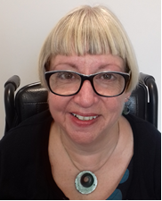
Caron Walker

Caron is an Assistant Director for Public Health as well as a Consultant in Public Health. She works across all areas of public health on the prevention agenda with statutory and voluntary sector partners; she has a particular interest in the wider issues that impact on health and well-being and leads on health improvement, health protection and emotional well-being for public health. She is a passionate advocate for singing for health and was instrumental in setting up workplace choirs in Newcastle and Calderdale.

Caron has had a varied career in the public and voluntary sectors having worked in a range of roles in local government, health, academia and voluntary sector organisations in the North East. Before joining Calderdale four years ago, she was a programme leader at Sunderland University, establishing BSc and MSc programmes in Public Health. During this time she was also the Independent Chair for Northumberland’s Safeguarding Adults Board.

She is a Fellow of the Faculty of Public Health, registered with the UK Public Health Register and has recently joined the Royal Society of Public Health’s Special Interest Group on arts and health. She also chairs the Yorkshire and Humber Community of Improvement around Mental Health and Suicide Prevention. It will be no surprise that she has degrees in Applied Policy Research and Politics.

Susan Halstead

Susan Halstead is a National Practice Lead at Pause with responsibility for practices in the north east. Susan has an MA in Social Work and prior to joining Pause worked as a Children’s Guardian in the family courts and was a practice supervisor and member of the national improvement service at the Children and Family Court Advisory and Support Service (Cafcass).

As a social worker, Susan worked in child protection, education social work and leaving care teams in North Yorkshire.
Susan has delivered training for the Leeds Safeguarding Children’s Board and is also the safeguarding lead for Home Start York where she has been on the board of trustees since 2013.

Jack Czauderna

Jack is a retired Family Doctor and Chair of Darnall Wellbeing, a community Health and Wellbeing group dedicated to improving the health of local communities in East End Sheffield. He is also Chair of The Pioneer Health Foundation, a small charity which keeps alive the legacy of the famous ‘Peckham Experiment’.

He was born near London, of Polish parents and studied medicine in Bristol. He was a GP in Darnall, in East End Sheffield for almost 30 years but realised along the way that the absence of disease and disorder is not the same thing as health. Just as Tony Benn stopped being an MP to devote more time to politics, he stopped being a GP to devote more time to health.

He would like to see a reinvigorated and refunded NHS with a strong public health ethos and a ‘Peckham Experiment’ type facility in every community.

Khawaja Waqas Hameed

Waqas became a Community Health Champion (volunteer) in 2009 which enabled him to further his training and also to support people from the community. Just before completing the 100 hours he was appointed to the Health Trainer job because of his training, work experience and his multi lingual skills.

Waqas started work for Darnall Well Being (DWB) as a health trainer in January 2010 and later became a senior health trainer; he has been involved in various successful pilot projects including Chronic Pain Initiative and EPCC (enhanced primary and community care) and Virtual Ward. Apart from his health trainer role he is also involved with DWB social prescribing project to enhance client involvement, participation and delivery. Waqas will also support the Evaluation process for social prescribing clients.

Lucy Melleney

Lucy is the Chief Executive Officer of Darnall Well Being (DWB) – a local, community health and wellbeing organisation (est. 2000), working to tackle inequalities in one of the most deprived and diverse areas of Sheffield. Lucy has led the development of the organisation and team of 12 staff and 30 volunteers, since November 2008 and supports good staff and volunteer retention, working successfully to build excellent credibility and reputation for both the organisation and her leadership.

Key project management experience over the last ten years includes the development of the Health Trainer Service (1to1 support), Health Champion volunteer schemes, Social Prescribing and most recently a three-year Slovak Roma Health Project, which combined asset-based community development principles with DWB’s unique relationship with primary care (co-located within a GP surgery).

Lucy’s passions are building cohesive communities, addressing health inequalities head-on and harnessing local assets, so communities thrive on their own terms. Building strong relationships within and across organisations, services and community is at the core of her strategic approach.

This promotes maintaining trust and strong relationships with the community (both residents and organisations) and deepens understanding of the culture, needs and complexities of the area and how to overcome them.

Lucy has always been interested in grassroots, active citizenship and the power of bringing people together with a shared purposed. This led to volunteer roles such as coordinating the first ‘Peace & Solidarity in the Park’ festival in the city, in 2003 (still going today) and work with an asylum seeker support initiative (ASSIST) and more recently, as a funding officer at her local Scout group and helping to run a weekly Social Café, which provided a low-cost, healthy meal and safe space for local people.

Lucy is also the Development Manager of Green City Action (charity est. mid 1990s), which works to promote community wellbeing, access to food-growing and environmental education in the North of Sheffield.

