


Community, Culture and Health

‘A Christmas Carol’

11th December 2018

Conference Evaluation Report
How did you rate the following aspects of this event?

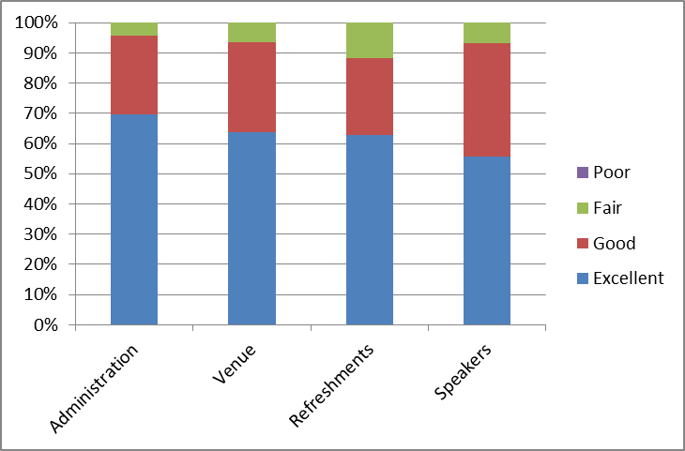
How did you feel presentations cover the issues in relation to the focus of the event?

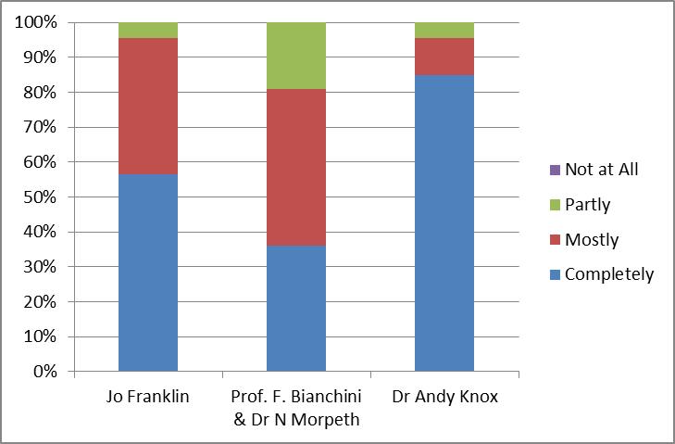

How did you feel presentations cover the issues in relation to the focus of the event?

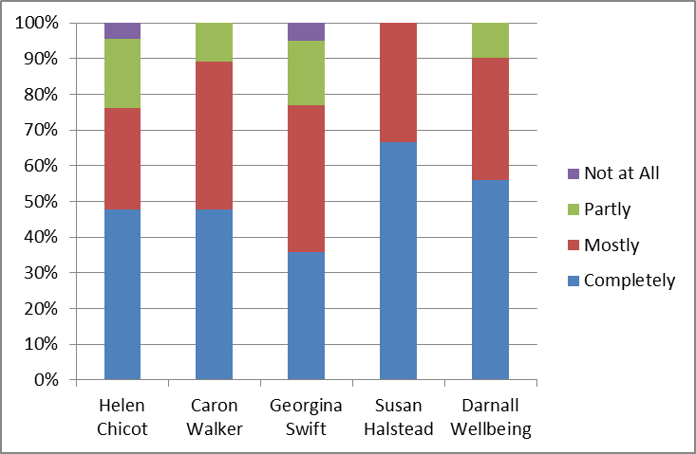

What aspect of the day did you particularly like?

- All good.
- The presentations
- Range of information about different approaches
- Andy Knox, I would of liked him to have a longer session to explore some of his theories. The role of volunteers in Hull is ongoing training
- The input from Dr Andy Knox was fabulous, maybe more input from 'real people'.
- Andy Knox and Susan Halstead? Were both worth the trip
- Andy Knox hit the nail on the head and was passionate
- Dr Andy Knox I could have listened to him all day.
- Good atmosphere.
- A presentation with a focus on new and innovative ways of working.
- Dr Andy Knox was very inspirational. Workshops to learn about different projects and learning from these.
- Dr Andy Knox presentation.
- Presentations interesting, relevant content, Dr Andy Knox was very thought provoking.
- Dr Andy Knox was fab!
- Andy Knox presentation was excellent. Good to hear from everyone around the region
- I like the David Knox stuff
- Particular like studies on people being supported to engage in community healthcare.
- Presentations, Andy Knox presentation, workshops
- Info on city of culture experience, Dr Knox talk
- Andy’s talk inspirational
- Andy Knox presentation
- Population health talk
- Dr Andy Knox very inspirational
- Special mention to Helen Chicot, wanted to hear more case studies
- Dr Andy Knox very refreshing
- Dr Andy Knox very refreshing, honest and challenging
- Inspirational Dr Andy Knox
- The chance to meet other colleagues from other authorities/organisations. Excellent workshops. The lunch was exceptional.
- Andy Knox presentation awesome
- Enjoyed the talk from Andy Knox proactive and enthusiastic
- Dr Andy Knox was very inspirational and thought provoking
- Great venue, informing presentations
- Presentations with more of a focus
- Andy Knox was absolutely brilliant
- Andy Knox spoke with passion
- "The passion of Andy Knox. Location, logistics and spaces were very good”
- Andy Knox presentation
- The talk by Dr Knox

How could we improve future events?

- More opportunities to ask more questions in workshops. More opportunities to look at how outcomes + impact of culture + arts on improving wellbeing.
- At times it was difficult to hear people especially in the workshops
- Display information to take away, sharing the work going on in Hull and from the different speakers.
- I’m not sure the venue was well I had some difficulty leaving the small group numbers were too big.
- Lack of interaction during workshop during session
- Too much to expect speaker to do couldn’t hear the worshops.
- Use a community venue
- Few links to culture in some workshops. Some workshops didn’t explain what they actually did what evaluation actually showed.
- More CCG representation in delegates to engage in inequalities agenda.
- Biscuits, Fruit
- More particular work and more art not just health
- More chances to ask questions following the workshops
- Agenda felt a bit too full also it would have been good to have more interactive parts of the day. Snacks at break especially in the morning.
- Many of the presentations after lunch I had problems hearing due to the speakers.
- Microphones for presenters in the workshops, could not always hear what was being said.
- Disappointing to not have the presentation from Jenny Popay.
- Cleared the fog!
- Timings
- Use microphones
- It was well organised and enjoyable, although one or two of the workshops felt a little bit dry.
- Some refreshments healthy snacks
- Snack food with tea/coffee, heating it was cold. Some workshops were unengaging and lacked culture reference
- Use a community venue
- More opportunities to ask more questions
- I was hoping for a much more focused look at culture and wellbeing, but felt that this didn’t come through that strongly as a theme, and where it was explicit in Franco and Nigel’s presentation it offered a very particular and almost bleak view of the impact of culture and arts on wellbeing – a little balance may have helped
- I enjoyed the event and would like it to continue to deliver more discussions/talks around how we can challenge/address major barriers in delivering good outcomes or alternative systems of organisation.

For future events are there any topics you would like to see covered?
- Sustainability
- Focus on gypsy and traveller’s health and wellbeing. Links between health and employment poor health and mental wellbeing. There is no safety net and people are suffering.
- Universal credit.
- Dr Andy Knox could do a whole day
- More emphasis on early years and life by impacts
- Will have a think and email
- Engagement with young people around the health and well being
- Shit- life syndrome in the Blackpool
- Lack of buy in from primary care
- Further work around arts, culture, health and wellbeing
- "Innovative ways to address health conditions. Environmental issues and healthcare"

Any other comments?

- Very good day and good platform to do networking
- Could we have the slides emailed to us as four of them were hard to read? More interaction please.
- The gap for carer’s immense. The carers are being forgotten, hidden, suffering, tired. The lack of meaningful funding for social care. 1 in 12 people in the population are age 80+ their children are caring for them unpaid.
- Some good things. But the day didn’t have the coherence of some of the others.
- Just needed more time felt rushed
- More networking opportunities
- My first minding the gap event I have attended excellent event thank you
- Enjoyed seeing the different approaches that were taken to solve common problems inequalities some very inspiring.
- Thanks for a good day!
- Thanks for a great day
- Thank you
- Thank you enjoyed the day
- Another excellent event
- I enjoyed the conference thank you
- Well done Ian
- More networking opportunities
- Really interesting and useful conference
- Thank you, notwithstanding the above I enjoyed a great day full of inspiration and learning.
- Many thanks for organising these important events

