Scarlet Fever Template Letter for Parents
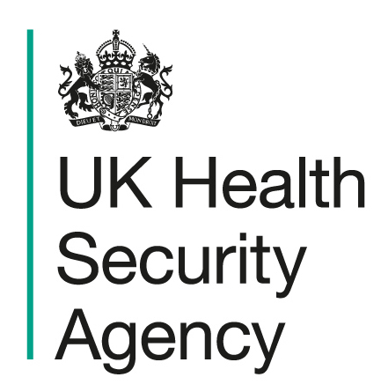 | EDIT TO SUIT LOCAL CONTEXT OR REMOVE e.g. Schools to add their own details and logo if sending out to parents / carers  Service/team  First address line  Second address line  Town/city Postcode  T +44 (0)20 0000 1234  F +44 (0)20 0000 1234  www.gov.uk/ukhsa

00 Month 20XX
Dear parent or carer,

There have been cases of scarlet fever in [name of setting]
What this means for your child
- most children stay well
- if your child has no symptoms, they can keep going to school or nursery as normal
- scarlet fever is easy to treat when caught early
We are sharing this information, so you know what to look out for and what to do if your child becomes unwell.

Signs to look out for
Scarlet fever often starts like a sore throat or flu.
Your child may:
- have a high temperature
- have a sore throat
- have swollen glands in the neck
- feel unwell or tired
A rash appears 1 to 2 days later:
- small, raised bumps
- starts on the chest or tummy, then spreads
- feels rough, like sandpaper
- looks pink or red on white skin
- may be harder to see on brown or black skin, but you can still see and feel the rough bumps
- cheeks may look red
If you think your child has scarlet fever:
- your child should stay at home because they could be infectious
- contact your GP or NHS 111 as soon as possible and describe your child’s symptoms. Let them know that there is a scarlet fever outbreak at your child’s school / nursery.
- if your child has scarlet fever, they will be prescribed antibiotics. Make sure your child finishes the full course of antibiotics, even if they feel better.
These will:
  - help your child get better quicker
  - reduce the chance of a serious illness
  - make it less likely that your child will pass the infection on to someone else
- your child should stay at home until at least 24 hours after starting antibiotics
Early treatment helps your child recover faster and stops the infection spreading to others.
Children with other health needs
If your child has a long term or a complex medical condition, please speak to your GP or hospital doctor. They may need to give extra advice or medicines.
When to get urgent help
Scarlet fever is usually mild, but some children can get seriously ill. This is more likely if they have chickenpox or flu at, or around, the same time as scarlet fever.
Call 999 or go to A&E if:
- your child is having difficulty breathing – they may make grunting noises, be breathing very quickly, or you may notice their tummy sucking under their ribs
- there are pauses when your child breathes
- your child's skin, tongue or lips are blue or grey – on black or brown skin this may be easier to see on the palms of the hands or soles of the feet
- your child is floppy and will not wake up or stay awake

If your child has chickenpox
Keep them at home for at least 5 days after the rash starts AND until all spots have crusted over.
More information
Read the scarlet fever factsheet included at the end of this letter. You can also visit the NHS website. https://www.nhs.uk/conditions/scarlet-fever/
Yours sincerely,

Author’s name
Position/Title
Email address

