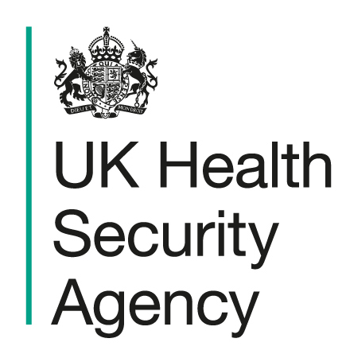

Children & Young People settings

Acute Respiratory Infection (ARI)

Action Card
To be used in conjunction with Health protection in children and young people settings, including education - GOV.UK

Signs and symptoms | Symptoms of a respiratory tract infection include: a cough – you may bring up mucus (phlegm), sneezing, a stuffy or runny nose, a sore throat, headaches, muscle aches, breathlessness, tight chest or wheezing, a high temperature, or feeling generally unwell.
Transmission Route | Person to person spread through the air and through direct contact. Surfaces and belongings can also be contaminated when people with the infection cough or sneeze or touch them. The risk of spread is greatest when people are close to each other, especially in poorly ventilated indoor spaces.
Exclusion | Guidance for children in educational settings is included in People with symptoms of a respiratory infection including COVID-19 - GOV.UK.  - Children and young people who are unwell and have a high temperature should stay at home and where possible avoid contact with other people. They can go back to an education or childcare setting when they no longer have a high temperature, and they are well enough.  - Children with mild symptoms such as a runny nose, sore throat, or mild cough, who are otherwise well, can continue to attend their education or childcare setting.  - It is not recommended that children and young people are tested for COVID-19 unless directed to by a health professional.  - If a child or young person has a positive COVID-19 test result they should try to stay at home and where possible avoid contact with other people for 3 days after the day they took the test.  - Adults with a positive COVID-19 test result should try to stay at home and avoid contact with other people for 5 days.  - Children and young people who usually go to school, college or childcare and who live with someone who has COVID-19 or another respiratory illness such as flu should continue to attend as normal unless they become unwell.
Closures | It is not necessary to close the school unless there are operational reasons such as significant staff absence. This would be a decision for the school in conjunction with the relevant educational authority.
Recommended actions for limiting transmission
Hand and respiratory hygiene | - Children should be supervised and/or encouraged to wash their hands regularly.  - Hand washing with liquid soap and warm water preferred over alcohol gel.  - Paper towels or hand dryers should be used for drying hands (and a wastepaper bin provided for disposal of towels if applicable).  - Encourage good respiratory hygiene (using and disposing of tissues)  - Remind staff to wash their hands throughout the day. Hand washing needs to be done after changing nappies and helping children use the toilet.  - e-Bug | England Home has a range of educational resources for ages 3-16 to learn about microbes, infection prevention and control, antibiotics and vaccination.
Cleaning and disinfection | - Regular cleaning using standard cleaning products such as detergents are an important part of reducing transmission.  - Frequently touched surfaces such as door handles, light switches and work surfaces should be wiped down twice a day and one of these should be at the beginning or the end of the working day.  - Cleaning frequently touched surfaces is particularly important in bathrooms and kitchens.  For more information see Preventing and controlling infections - GOV.UK
Ventilation and use of outdoor space | Consider use of outdoor spaces if possible.  Ensure occupied spaces are well ventilated and let fresh air in. Further information: Ventilation to reduce the spread of respiratory infections, including COVID-19 - GOV.UK
Communications | In the event of an outbreak, consider communications to raise awareness among parents and staff and reinforce key messages:  - encouragement of vaccination where appropriate (resources available childhood immunisation toolkit)  - use of hand and respiratory hygiene measures (utilise handwashing posters, and Catch it, Bin it, Kill it Poster).
Reporting to UKHSA / HPT
When to contact your local Health Protection Team (HPT)  (This does not replace any local reporting arrangements with local authorities or other partners) | Please contact your local Health Protection Team if:  - there is evidence of severe disease due to respiratory infection, for example if a child, young person or staff member is admitted to hospital,  - you are concerned about the number of staff or student absences due to acute respiratory infection, or you are concerned that it is increasing unusually fast,  - there are other infections also circulating in the same group of people, such as scarlet fever  - you are a SEND or other setting with children who are clinically vulnerable and there are cases with positive tests for flu.  NOTE: If none of the above apply, you do not need to contact the Health Protection Team

