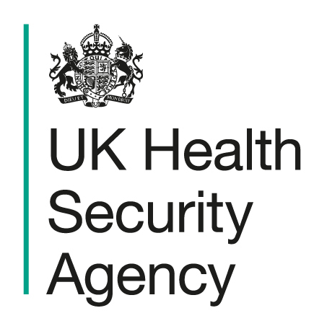

Children & Young People settings

Chickenpox

Action card
To be used in conjunction with Health protection in children and young people settings, including education - GOV.UK

Signs and symptoms | Chickenpox usually begins with a high temperature, aches, and loss of appetite, followed by an itchy rash. The rash develops in stages, starting as small spots that turn into fluid-filled blisters before forming scabs. Spots can appear anywhere on the body and may be at different stages at the same time.
Transmission Route | Spreads easily from person to person through the air (when virus aerosolises from the blisters of an infected person) and by direct contact with fluid from the blisters. People are infectious from up to 1 day before the rash appears until all the spots have formed scabs
Exclusion | Exclude individuals with chickenpox for at least 5 days from onset of rash and until all blisters have crusted over, and the individual is well. Pregnant staff contacts should consult their GP or midwife. Immunosuppressed contacts should contact their GP or specialist.
Closures | It is not necessary to close the school unless there are operational reasons such as significant staff absence. This would be a decision for the school in conjunction with the relevant educational authority.
Recommended actions for limiting transmission
Hand and respiratory hygiene | - Children should be supervised and/or encouraged to wash their hands regularly.  - Hand washing with liquid soap and warm water preferred over alcohol gel.  - Paper towels should be used for drying hands and a foot-operated bin provided for disposal of used towels.  - Encourage good respiratory hygiene (using and disposing of tissues)  - e-Bug | England Home has a range of educational resources for ages 3-16 to learn about microbes, infection prevention and control, antibiotics and vaccination.
Cleaning and disinfection | - Regular cleaning using standard cleaning products such as detergents are an important part of reducing transmission.  - Frequently touched surfaces such as door handles, light switches, work surfaces and toys should be wiped down frequently  - Wash contaminated clothing/bedding at 60°C.
Ventilation and use of outdoor space | Ensure occupied spaces are well ventilated and use outdoor areas where possible.
Activities | Avoid sharing soft toys and dressing-up clothes during increased illness; wash items regularly
Communications | When two or more cases occur in a class or defined mixing group, send an information letter to parents/carers with the factsheet. The letter should be edited where highlighted to reflect the circumstances in your setting. The letter highlights:  - importance of strict exclusion periods for cases  - increased risk of severe Group A streptococcal disease when chickenpox circulates alongside scarlet fever  - importance of vaccination with MMRV to available age groups.
Reporting to UKHSA / HPT
When to contact your local Health Protection Team (HPT)  What UKHSA will ask for | Please contact your local Heath Protection Team if:  - there are high-risk exposures (pregnant women, immunocompromised people, neonates)  - severe disease, hospitalisation or unusual complications occur  - chickenpox is co-circulating with scarlet fever (getting both infections together could lead to more serious illness)  - advice is required on post-exposure prophylaxis (PEP) for vulnerable contacts.  Name and address of the setting, contact details; total numbers of children and staff; affected classes/groups; number of cases and dates of symptom onset; details of vulnerable individuals; setting layout and mixing patterns; and any recent events or trips.  For settings with children born on or after 1 January 2020, the overall MMRV uptake, if known.

