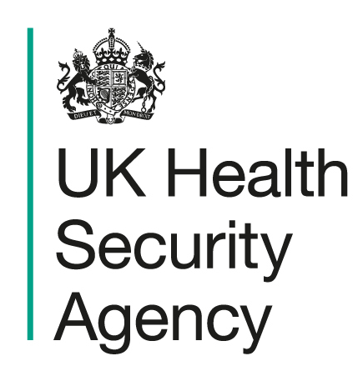

Children & Young People settings

Hand, Foot and Mouth Disease

Action card
To be used in conjunction with Health protection in children and young people settings, including education - GOV.UK

Signs and symptoms | Usually starts with a sore throat, high temperature, and reduced appetite. A few days later, painful mouth ulcers develop, followed by a rash of spots on the hands and feet (and sometimes the bottom or groin), which can turn into small blisters. Symptoms are usually mild and clear within 7 to 10 days.
Transmission Route | Spread through respiratory droplets (coughs and sneezes), direct contact with saliva or fluid from blisters, contaminated surfaces, and the faecal-oral route (for example during toileting or nappy changing).
Exclusion | No exclusion required if the child is well enough to take part in normal activities. Children should stay at home if they have a fever or are otherwise unwell and can return when they are feeling better. Keeping them away for longer is unlikely to stop the illness spreading.
Closures | It is not necessary to close the setting. Infection is usually managed within the setting.
Recommended actions for limiting transmission
Hand and respiratory hygiene | - Children should be supervised and/or encouraged to wash their hands regularly.  - Hand washing with liquid soap and warm water preferred over alcohol gel.  - Paper towels or hand dryers should be used for drying hands (and a wastepaper bin provided for disposal of towels if applicable).  - Do not share towels  - Encourage good respiratory hygiene (using and disposing of tissues)  - e-Bug | England Home has a range of educational resources for ages 3-16 to learn about microbes, infection prevention and control, antibiotics and vaccination.
Cleaning and disinfection | - Regular cleaning using standard cleaning products such as detergents are an important part of reducing transmission.  - Clean frequently touched surfaces such as door handles, light switches, and work surfaces, and shared items, including toys  - Dispose of nappies and tissues safely and clean contaminated areas promptly.  - Wash contaminated clothing/bedding at 60°C.
Ventilation and use of outdoor space | Ensure indoor spaces are well ventilated and increase use of outdoor space where possible.
Activities | Avoid activities that involve close contact or sharing items (e.g. utensils, cups, sensory play materials) while symptoms are present. Clean items regularly.
Communications | Send an information letter and factsheet to parents/carers of cases and reinforce hygiene messages and keeping unwell children at home. Display handwashing posters
Reporting to UKHSA / HPT
When to contact your local Health Protection Team (HPT)  What UKHSA will ask for | Please contact your Health Protection Team if:  - large numbers of children are affected  - severe or unusual illness occurs  - advice is required  Setting details, number of cases, affected groups, onset dates and any vulnerable individuals.

