Hand, Foot and Mouth Disease - Template Letter to Parents

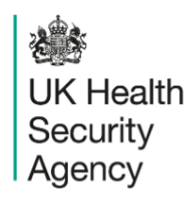 | EDIT TO SUIT LOCAL CONTEXT OR REMOVE e.g. Schools to add their own details and logo if sending out to parents / carers  Service/team  First address line  Second address line  Town/city Postcode  T +44 (0)20 0000 1234  F +44 (0)20 0000 1234  www.gov.uk/ukhsa

00 Month 20XX
Dear parent or carer,

There have been cases of Hand, Foot and Mouth Disease in [name of setting]

What this means for your child
- most children stay well
- if your child has no symptoms, they can keep going to school or nursery as normal
- hand, foot and mouth disease is usually mild, and most children get better on their own
We are sharing this information, so you know what to look out for and what to do if your child becomes unwell.

What you can do
You can help stop it spreading and help your child feel better:
- keep your child at home if they feel unwell or have a fever
- encourage regular handwashing with soap and water
- make sure your child drinks plenty of fluids
- check your child daily for symptoms
Your child can go back to school or nursery once they feel well enough to take part in normal activities, even if they still have some spots.

When to get help
Get advice from your GP or NHS 111 if:
- you are worried
- your child is not drinking well
- symptoms seem to be getting worse

More information
Read the hand, foot and mouth disease factsheet included at the end of this letter. You can also visit the NHS website: https://www.nhs.uk/conditions/hand-foot-mouth-disease/.

Yours sincerely,

Author’s name
Position/Title
Email address

