UKPHR Public Health Practitioner Registration Scheme
Assessor Application Pack

The Yorkshire and the Humber (Y&H) Public Health Practitioner Registration Scheme is currently recruiting for new Assessors to be trained by the UK Public Health Register (UKPHR) to undertake practitioner portfolio assessment. Assessors are appointed by the Board of the UKPHR (following satisfactory completion of mandatory initial training).

Role Description
- To independently assess applications for verification (and probable subsequent application for admission to the UKPHR) against the UKPHR’s public health standards for practitioner registration, including requirements for clarification or resubmission of evidence;
- To provide formal feedback and advice to applicants on the assessment of their evidence in a timely way as specified in the UKPHR guidance for practitioner registration;
- To make recommendations on whether or not applicants should be registered for the appropriate Verification Panel, normally via the local scheme co-ordinator;
- To participate in moderation and other quality assurance activities;
- To complete a minimum of one whole assessment per year;
- To attend quarterly assessor/verifier support groups organised by the Y&H.
- The UKPHR will provide assessor refresher training every 2 years.

Value and Benefits of becoming an Assessor

- Individuals trained will become a recognised UKPHR Assessor;
- Contribute to the development of public health careers for individuals;
- Support the professionalisation of public health practitioners;
- UKPHR certificated training and appraisal that can contribute to your own CPD – ‘trained to assess’, and for your on-going personal development;
- Enhances your understanding of how the full range and scope of public health knowledge and skills are applied to the implementation of public health interventions by practitioners;
- Broadens your appreciation of public health agendas, policies, roles, services and interventions in other areas – both geographical and service area;
- Develops a sound grasp of retrospective portfolio building which could help with your own future portfolio development.

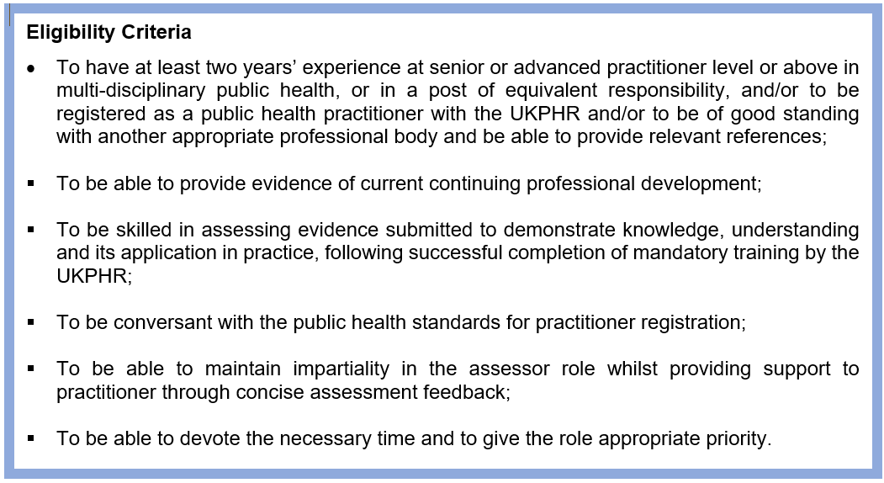

To apply for this role, please complete the attached form and return electronically to:
PHPPYH@leeds.ac.uk.

EXPRESSION OF INTEREST
UKPHR Practitioner Registration scheme Assessor
Please read the UKPHR Framework and Guidance for Practitioners, Assessors and Verifiers guidance before submitting this form
Your Details
Your name:
Title (Dr, Mrs, Mr):
Employing organisation:
Job Title:
Level of post Skills for Health
Work address with postcode:
Tel. No. | Work: | Mob:
Email address:

Your Employer
Line Manager’s name:
Title (Dr, Mrs, Mr):
Job Title:
Work address with postcode:
Email address:
Employing organisation:

Please detail in no more than 200 words why you would like to be trained as a UKPHR Assessor.

Responsibilities of the Assessor
Assessors and Verifiers are the custodians of the standards of practice for practitioners and their roles are of the upmost importance. The UKPHR provide training and moderation for these roles.

Declaration of commitment
Prospective Assessor | Line Manager
I have read the UKPHR Framework and Guidance for Applicants, Assessors and Verifiers.  I confirm that the information I have given is accurate and should I be accepted onto the scheme I agree to abide by its principles and to participate fully.  I commit to attending the UKPHR training.  I understand that this role is voluntary and commit to providing positive support to all candidates who I may assess in due course.  I am able to attend Assessor Training (Dates TBC). | I confirm that the organisation supports this expression of interest.  I confirm that the required time commitments for training and the assessment of one portfolio over 12-18 months will be fully supported, and will become a part of the applicant’s appraisal process and continuing professional development within the workplace.  I understand that this role is voluntary, and that the applicant will be dedicating some of their own time to carry out the assessment of portfolios to support the professional registration of practitioners. Thus making a highly valued contribution to the professional development of the PH workforce.
Applicant’s signature: | Line Manager’s signature:
Date: | Date:

Please use electronic signatures if sending by email.Please send your completed application form to: PHPPYH@leeds.ac.uk.

